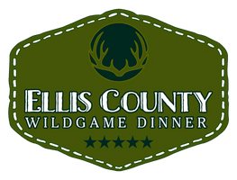

Wild Game Dinner
Project Grant Application

Applications are due October 10th, 2023
Instructions: Please complete the following application if you are a student involved in an Agricultural Livestock Project who will need assistance with funds to purchase an animal for the 2024 Livestock Show Season. Students must have the application signed by a parent and by his/her Ag Advisor to be eligible for the project grant. Please return this application to your Advisor on or before October 10th, 2023 A representative from the Wild Game Dinner will collect the completed applications directly from Advisors on the due date.
The committee will award grants for chickens, rabbits, goats, sheep and pigs (cattle excluded) for as many that are allowed through the budgeted funds raised from the Wild Game Dinner.

Name: ______________________________________
Address: ____________________________________ City: _____________________ Zip: _________
Parents Name: ________________________ Phone Number: _________________
School: ____________________________
Grade: ______
Advisor: __________________________________________
Advisor Email: ______________________________ Phone: __________________
Did you exhibit an animal at the 2023 ECYE? ___________

On a separate sheet, in one page or less, tell us: (must be typed and attached to this sheet)
- What species of livestock do you show?
- Why do you want to exhibit this project?
- How FFA or 4-H has helped you and why
you are in the organization?

Student Signature: ________________ Parent Signature: ________________ Advisor Signature: __________________

